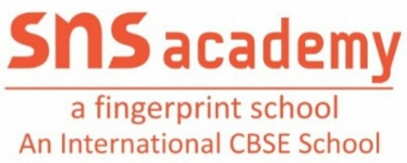
ANNUAL PLAN(2022-2023)
Grade: LKG Subject: ENGLISH
MONTH | UNIT/TOPIC
JUNE | - TIME FOR RHYMES  - FRIENDS ARE SPECIAL  - STROKES&CURVES - ‘I’, ‘—’, ‘)’, ‘(’  - RA THE RABBIT
JULY | - TIME FOR RHYMES  - NEHA WHO SAYS NO  - STROKES&CURVES - ‘U’, ‘\’, ‘/’, ‘O’  - RITU AND HER FAMILY
AUGUST | - THE PARK  - LETTERS(n,a,m)  - SHOW AND TELL DAY
SEPTEMBER | - BUNTU AND THE BIRD  - LETTERS(p,s,t)  - VENU’S NEW HOUSE  - FAMILY WORDS(-at and –ap)
OCTOBER | - AT THE FARM  - LETTERS(o,d,e,h)  - JILL’S SPECIAL DAY  - FAMILY WORDS(-et and –en)
NOVEMBER | - FLOWERS  - LETTERS(f,g,i,b,c)  - IF I WERE SMALLER  - FAMILY WORDS(-it and –in)
DECEMBER | - Mr.SHEEP’S PARTY  - LETTERS(r,u,l,v,w)  - BANJO WANTS A NEW TAIL  - FAMILY WORDS(-ub and –ut)
JANUARY | - WHERE IS CHINTU?  - LETTERS(j,k,y,q,x,z)  - THE HOT AIR BALLOON  - FAMILY WORDS(-ug and –un)
FEBRUARY | - LETTERS(a to z)  - FAMILY WORDS(-ad and –an)

Teacher Incharge: S.SWARNALAKSHMI

